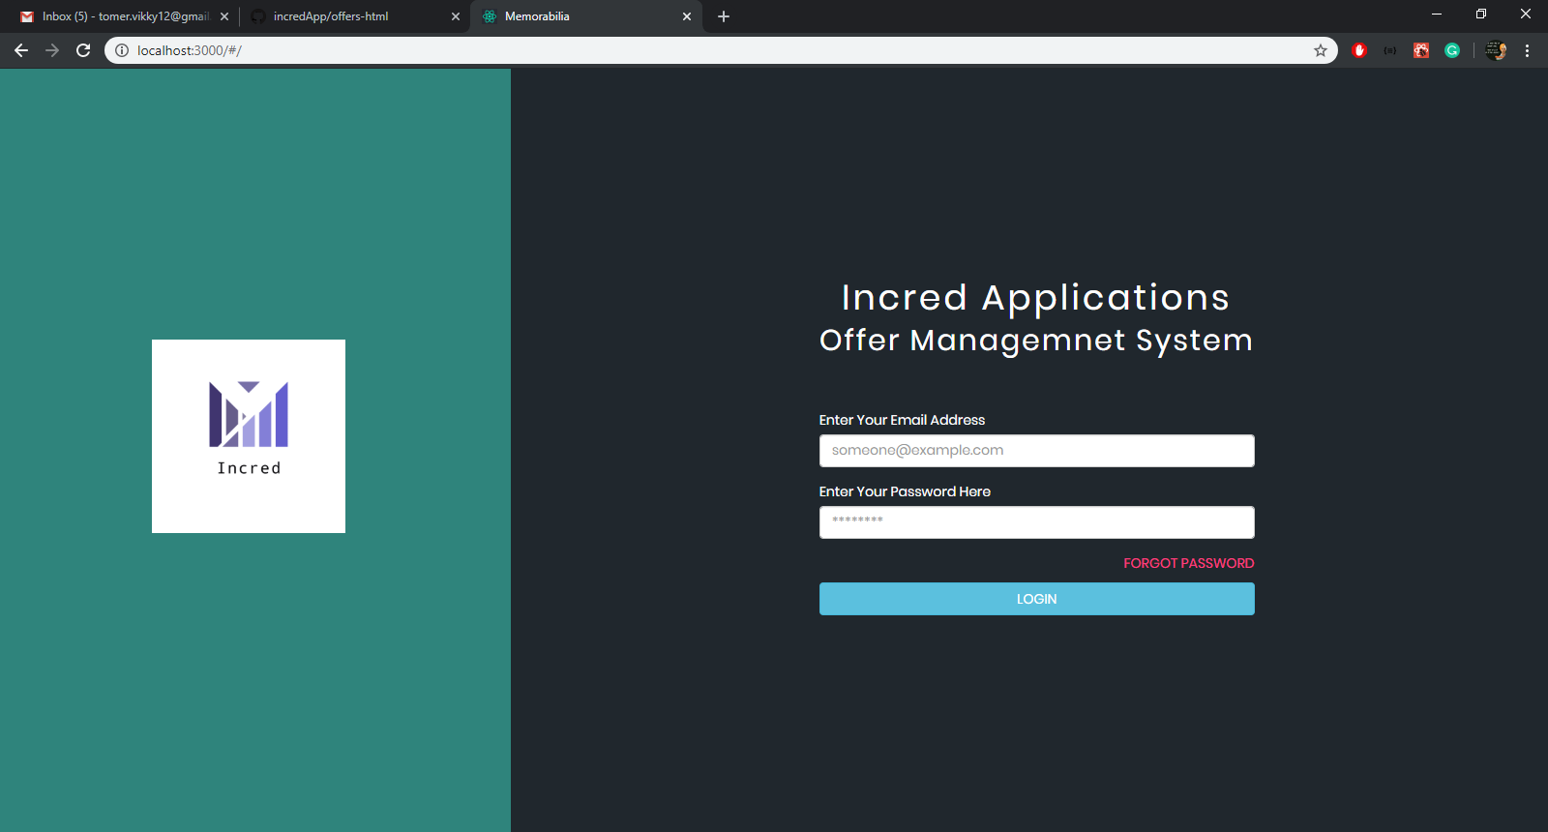

**Incred Applications Offer Management System (IAOMS)**

#### 1. Overview

The Incred Applications Offer Management System is a powerful, precise web based engine that runs a customer lead, customer transaction (payment through-put), Vendor Listing and Vendor Management system.

Incred Applications is a Community Applications based company that serves multiple communities and individual users. IAOMS sits inside these communities and from a single engine controls and manages content, customer interest tracking, customer leads and transaction details

A list of Sections IAOMS has are –

- Transactions Overview, Customer Inquiries, Manage Categories, Manage Vendors, Manage Networks, Admin Management, and IAOMS User Settings.

##### 1.1 Purpose

To build a high performance, scalable, modifiable and robust technology platform to deliver a precise transaction tracking, transaction search, system management and information delivery system to IAOMS users. In this document we have illustrated the various aspects of the IAOMS platform. It focuses on functionality, technical dependencies, risk involved and outcome of this project and how the modules interrelated between each other.



1. Landing/Sign In Page  
   Page Purpose: User Signs into System

* Two Fields of data entry for Phone Number and OTP, and 1 button for Log In Action
* Sign in can happen only via a phone number and OTP
* User can request a new OTP after 2 minutes
* Phone Numbers to access the IAOMS site can only be generated from the Admin Management page by Super Admins
* A countdown timer shows how much time the user has before expiry of OTP code

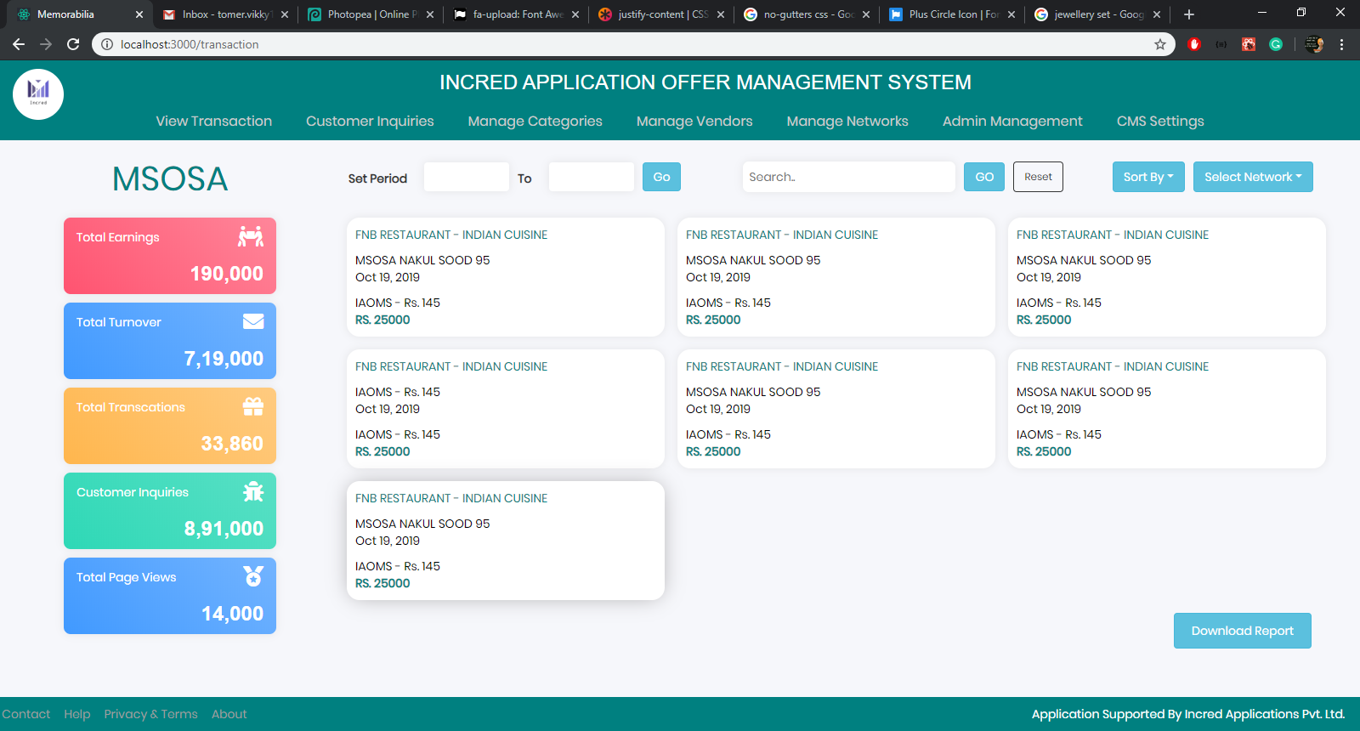

1. Transactions Overview  
   Page Purpose: User Reviews Macro Level Data on System, Searches for Specific Data and Prints/Downloads Reports

* On the left User can see 5 Snapshot values of Total Earnings, Total Turnover, Total Transactions, Total Listings Views, Total Section Views
* (Default Data displayed is for All Networks for the last 30 days)
* User can Generate/Filter data by date and network, category and vendor,
* User can also use Solr search to get results on individuals making purchases – eg. What items did Nakul Sood buy in this period
* User can reset results by using a **Reset button**
* Individual Transactions are displayed in a stamp on the page that lists the transactions category, vendors name, individual’s network and name, date, time and total amount of transaction and IAOMS net earnings
* There is no action on clicking on the stamp
* There is a **Button to download** the results data in search into a CSV sheet

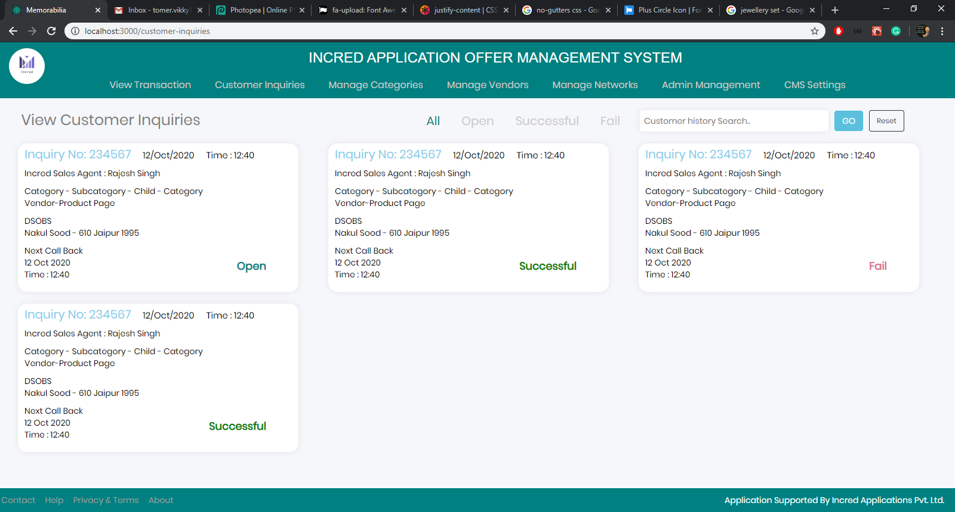

1. Customer Inquiries  
   Page Purpose: Incred Sales Agents can View/Manage Customer Inquiries, Search by Customer History

* (Enquiries by customers that fall under the sales agent category are listed here)
* **Clickable Stamp** has following Data: Inquiry no, Date and Time of Inquiry, Category and Vendor, Agent assigned to Inquiry, Customer’s Name, Identification and Network, Next Call Back Date and Time, Total Call Notes, And Status of Inquiry
* Filters on top allow the User to sort between All, Open, Successful and Failed enquiries
* Customer History Search allows User to search and see, by name, network, phone and email id customers past and current enquiries
* **An Agent drop down** (Currently not in design) list will allow User to sort enquiries according to which agents they have been assigned to which enquiries
* Clicking Stamp takes User to Customer Inquiry Detail

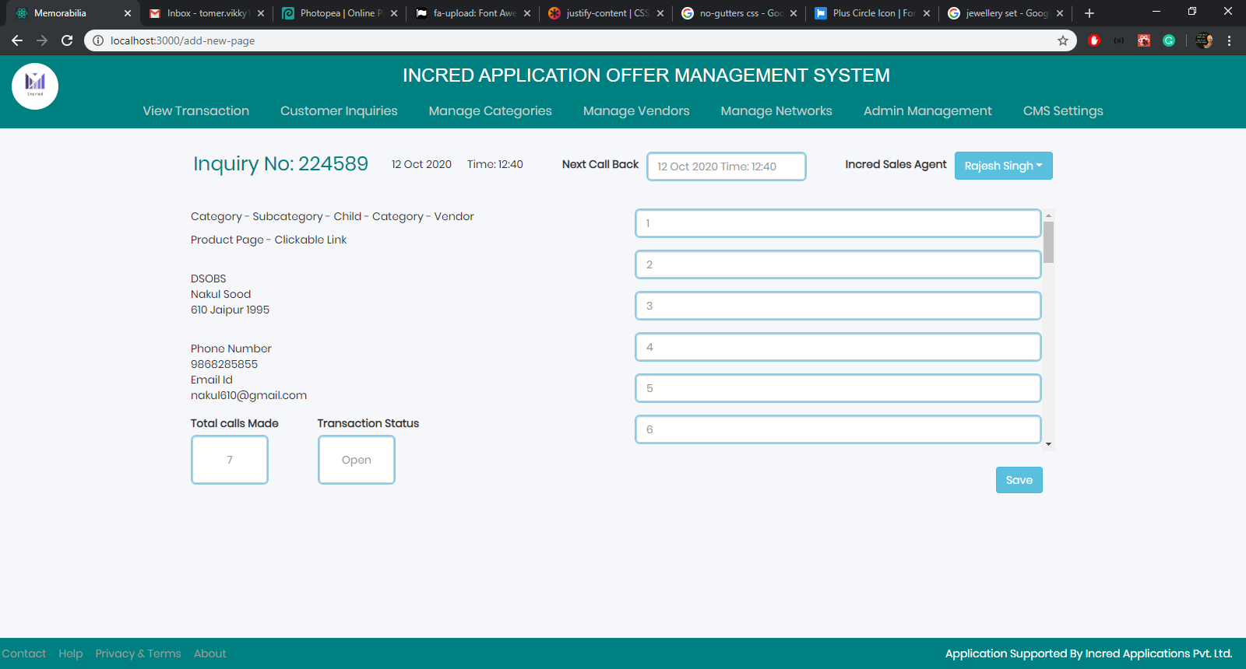

3a. Customer Inquiry Detail  
- Page Purpose: Intended for an Incred Sales Agent as User to view/manage a customer’s inquiry and for Super Admin to see a sales agent’s interaction and performance with a customer.  
- Page Displays Data on: Inquiry no, Date and Time of Inquiry, Category and Vendor, Agent assigned to Inquiry, Customer’s Name, Identification and Network, Phone No and Email Id, Next Call Back Date and Time, Numbered Editable Call Notes, Status of Inquiry (and Net Earnings form Successful sale).  
- **5 Editable Fields**: Numbered Call Notes, Next Call Back Time (Calendar and Clock), Total Calls Made, and Transaction Status  
**- 3 Buttons**: Save, View User Activity Log, And Super Admin Only ability to Assign/Reassign Sales Agent.  
- Give (Would You Like to Save This Page – Yes/No) notification if User is leaving page without saving changes

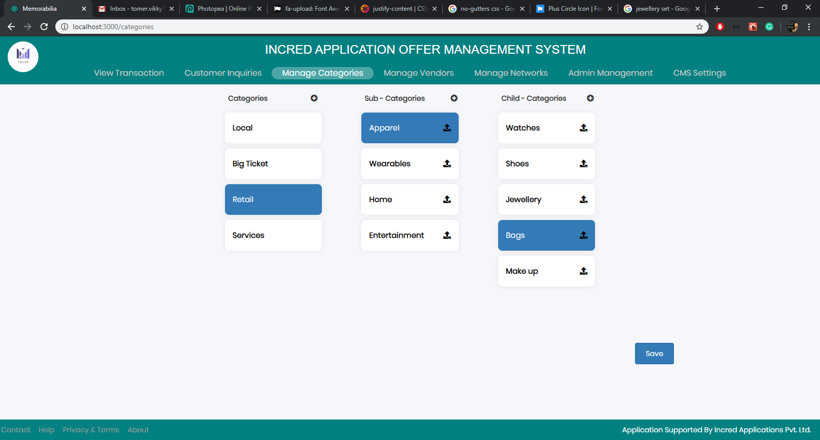

1. Manage Categories  
   Page Purpose: Allows Super Admin to Create/Edit and Manage Categories

* 3 Fields to Create/Edit/Manage - Master Categories, Sub Categories and Child Categories
* It is possible to Rename a category but you can only delete a category if there are no vendors assigned to that sub or child category
* Categories created and edited here are directly named and renamed into the front end communities IAOMS serves
* Once Categories are made or edited you have to click the **Save Button** for the changes to be stored in the database
* Give (Would You Like to Save This Page – Yes/No) notification if User is leaving page without saving changes
* Note: We have added an upload icon on Sub and child categories, we only need it on the Sub Category, this allows a user to upload an icon for that Sub category.

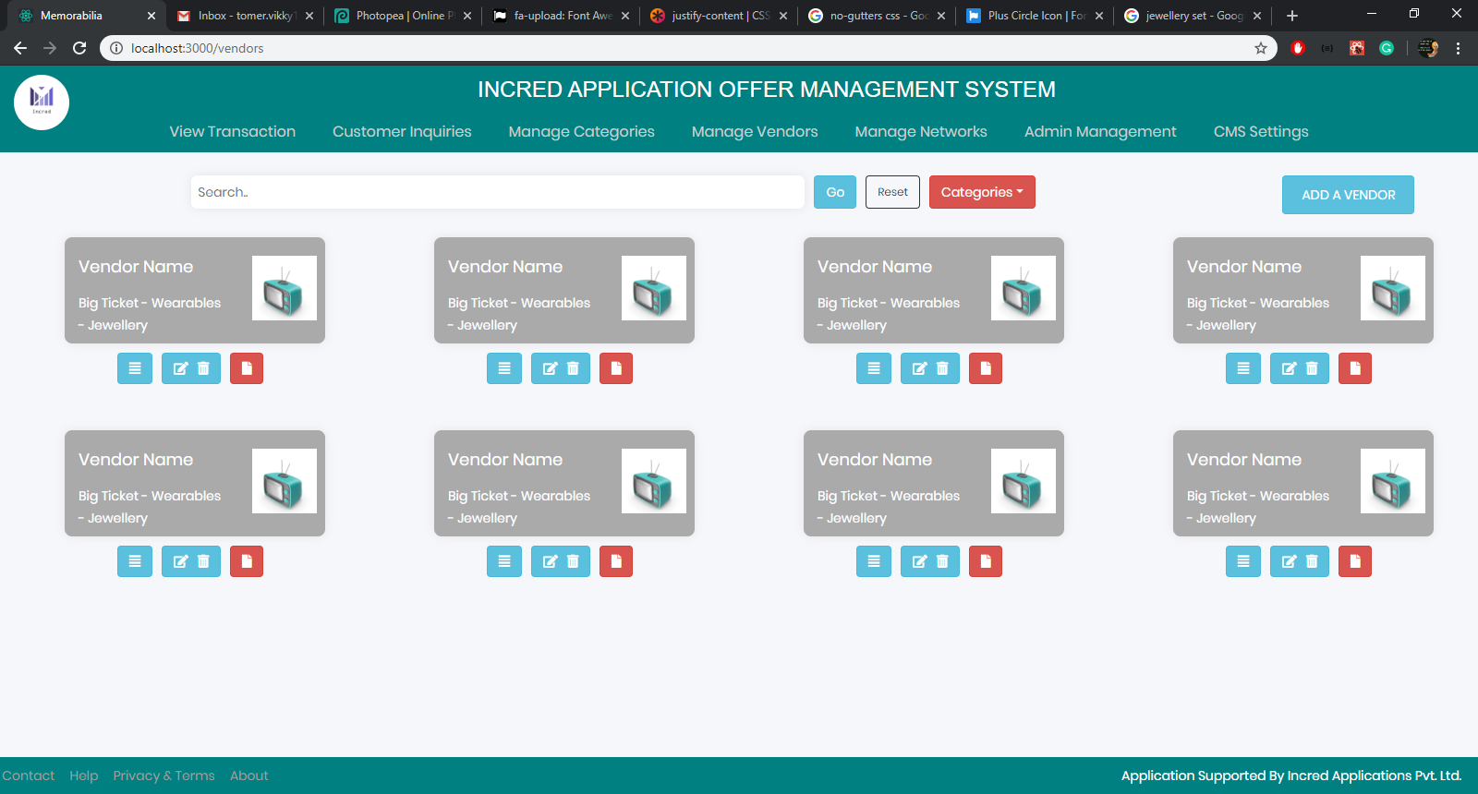

1. Manage Vendors  
   Page Purpose: Allow Super Admin to Create/Edit/Manage Vendors in system, View Activity Logs and Vendor Analytics

* **Clickable Stamp** for all Vendors in alphabetical order, Stamp displays the Vendor name, and category they belong to
* 3 buttons below the stamp allow us to view the Activity Log, Edit/Delete the vendors details and View the vendor’s tracking metrics
* Page has Search Field allows a search through the vendors names; Sort (Vendors) by Categories; and to Reset search results
* **Add a Vendor** **Button** allows us to create a new vendor and to assign a categories and pages to that vendor
* My clicking on any vendors stamp you can edit details and pages assigned to that vendor

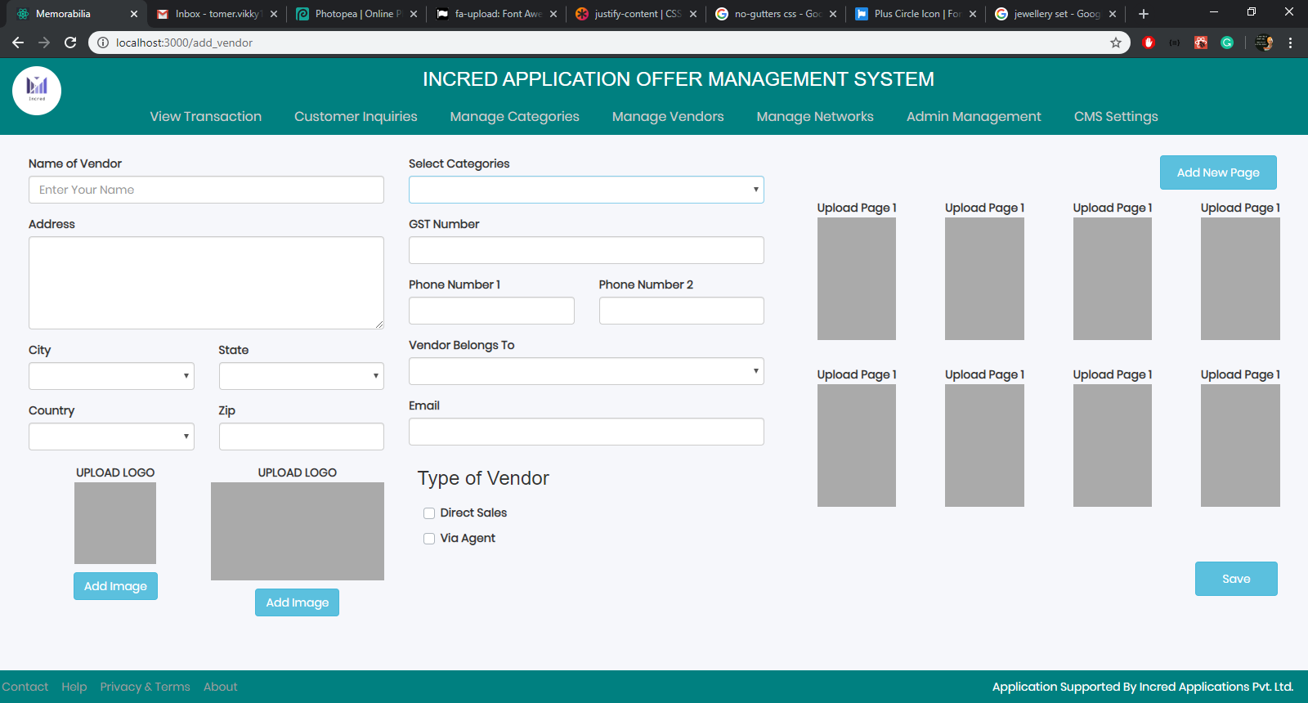

5a. Add / Edit a Vendor  
Page Purpose: This Page allows Super Admin to Edit a Vendors Details and to add Pages to that vendor that will be see in various Communities  
- **Editable Fields:** Vendor Details of Name, Address, City, State, Country, Zip, GST No, 2 Phone Numbers, Email and Logos   
- **Selection** of Type of Vendor as Direct Sales Vendor or a Via Agent Vendor distinction is made  
- **Clicking** on the Upload Page 1 button allows User to edit, upload images and data relating to that page  
- **Add New Pages** allows us to add more than 6 pages to a vendor  
- **Save Button** the data is saved, and stored in the database  
- Give (Would You Like to Save This Page – Yes/No) notification if User is leaving page without saving changes  
- Note: We have added a Vendor belongs to drop down, this allows us to say if the vendor personally belongs to a particular network. We will highlight this in the front end to increase page viewership as people would like to buy from businesses that are from their community.

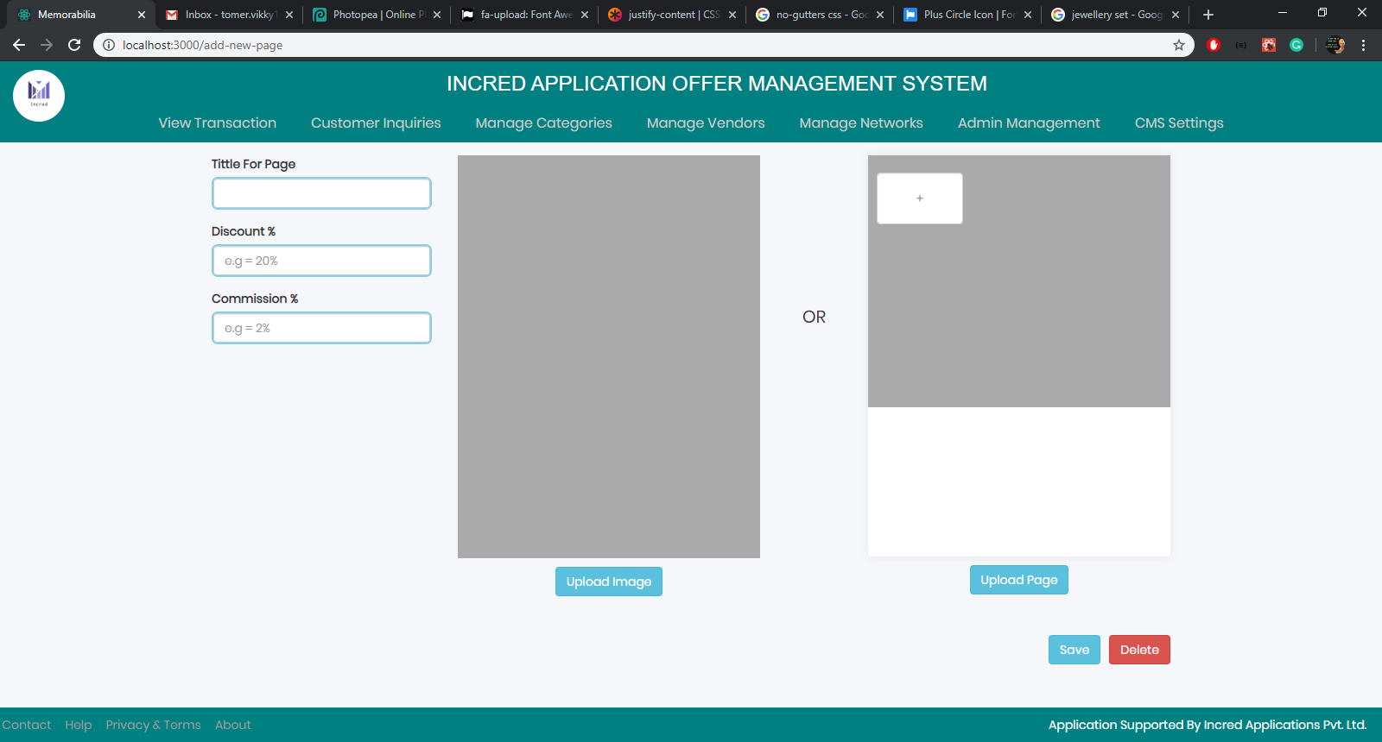

5b. Add / Edit A New Page  
Page Purpose: User/Super Admin can Create/Edit/Manage a Vendor’s page   
- **3 Editable Fields** Title of Page, Discount Value and IAOMS commission % associated with that page  
- User has to **Upload** either 1 photo that is a creative and says everything about that product or 2 **Upload** page, where User uploads multiple photos and write a descriptive text about the product   
- User clicks **Save Button** to save the data in the database   
- Give (Would You Like to Save This Page – Yes/No) notification if User is leaving page without saving changes  
- Note: We have added a Commission % that calculates and deducts a percentage of a transaction for IAOMS.   
- Note: We also might add a GST% rate that informs a customer or calculates a GST rate while through putting a transaction.

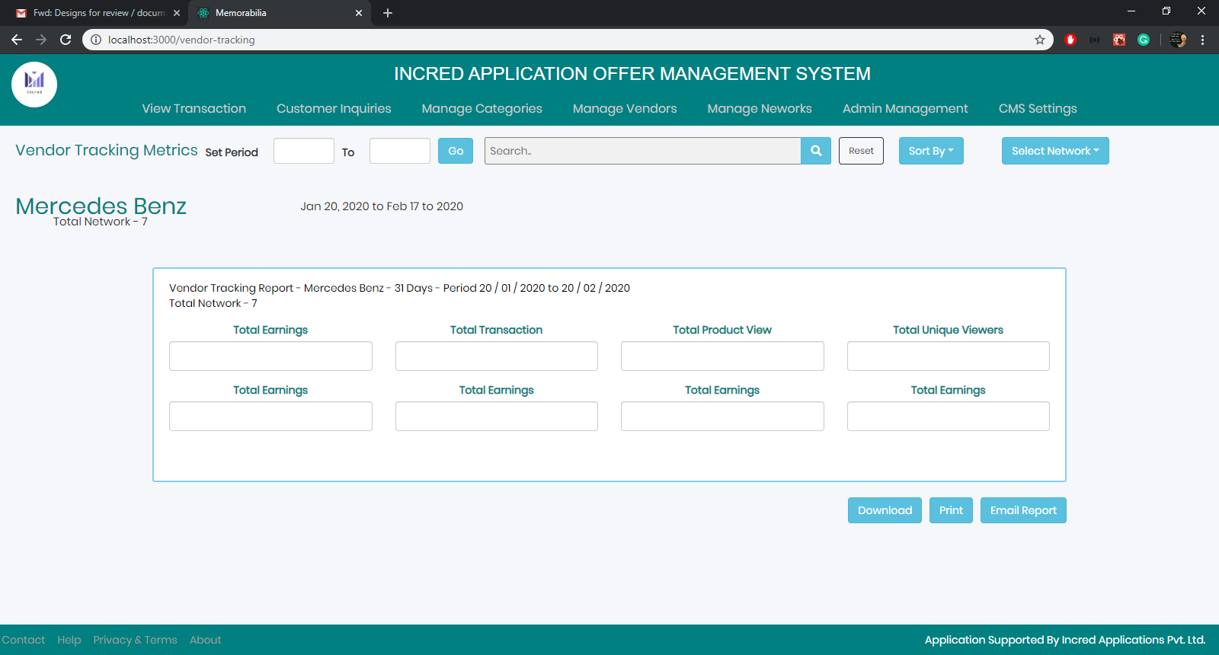

5c. Vendor Tracking Metrics  
Page Purpose: View Analytics and Performance of a Vendor, for a selected Period of Time  
- User **Sets date period** and clicks go to retrieve data for a vendor for a period  
- User can View all network results at once or via each individual network using the **select Network button**  
- Metrics display Total Transactions, Total Earnings, Total Product Views, Total Unique Viewers  
- User can **Download, Print or Email** these statistics in CSV format  
- Note remove search field from design

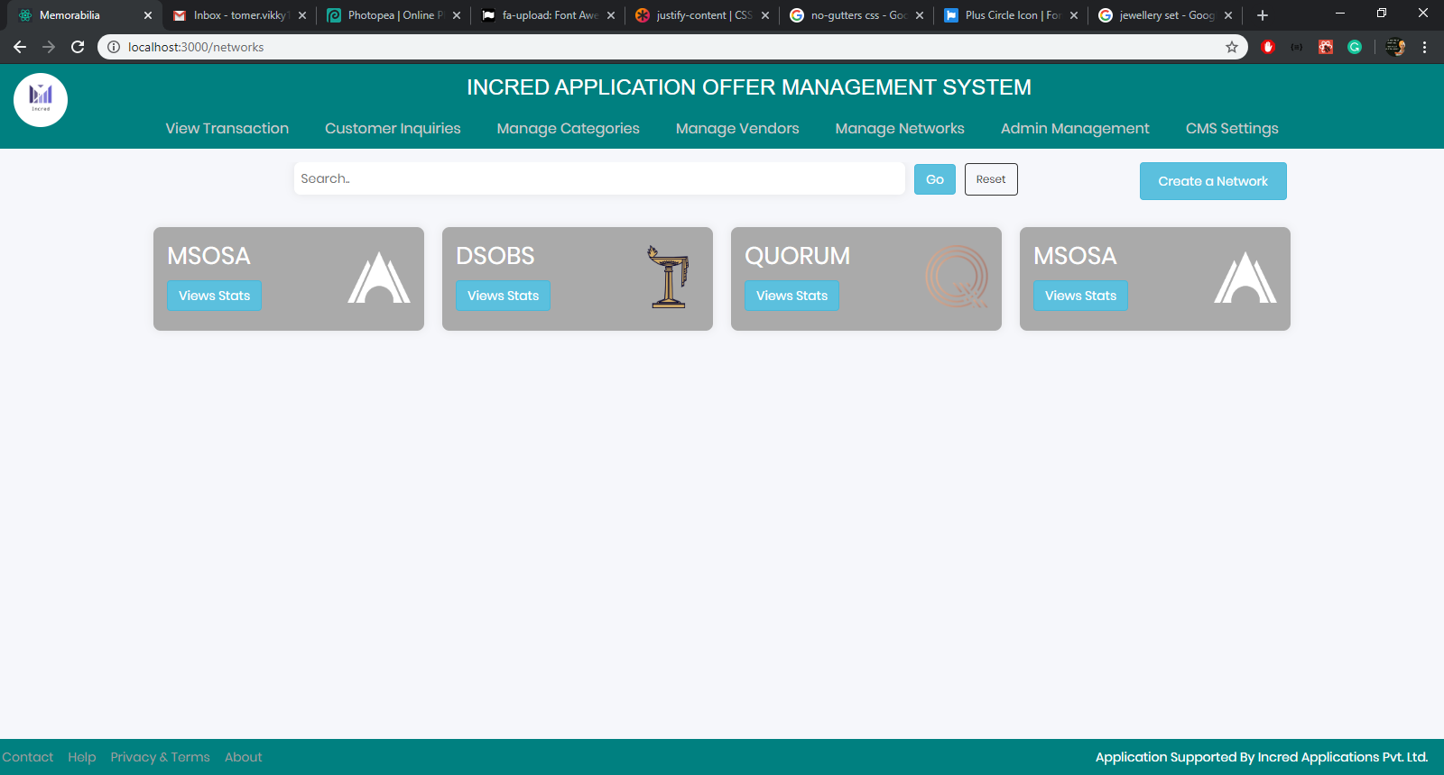

1. Manage Network  
   Page Purpose: Allow Super Admin to Create/Edit/Manage Vendors to a particular Network

* (Networks are created by the Communities Incred serves from different databases and servers)
* Search allows the User to find a network easily
* On **Clicking on the Stamp** User can Create/Edit/Manage Network Details or Add Vendors to the Network
* On **Clicking Create a Network** User can Add a New Network’s details and add new Vendors to that Network
* View Stats gives us statistics on the Network

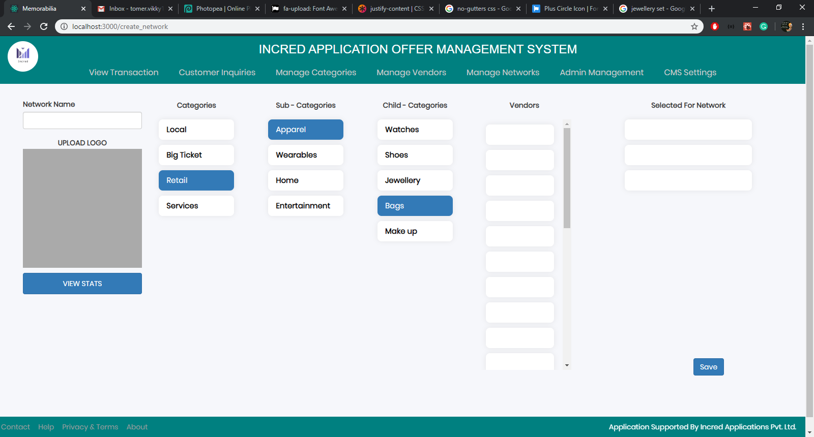

6a. Manage Individual Network  
Page Purpose: Edit Network Name and Logo on IAOMS and Assign Vendors to Network  
- User can Add or Edit a networks name for IAOMS and can Upload a Logo  
- Main purpose is to Add vendors to a particular Network  
- User can choose which vendors to add to which child category of a Network  
- On adding a vendor User has to add start and end date for Vendors display in Network  
- User clicks **Save Button** to save the data in the database   
- Give (Would You Like to Save This Page – Yes/No) notification if User is leaving page without saving changes  
- Note: On Clicking on Card for of Selected for Network vendor A field below the card opens that says start date end date and remove from network.

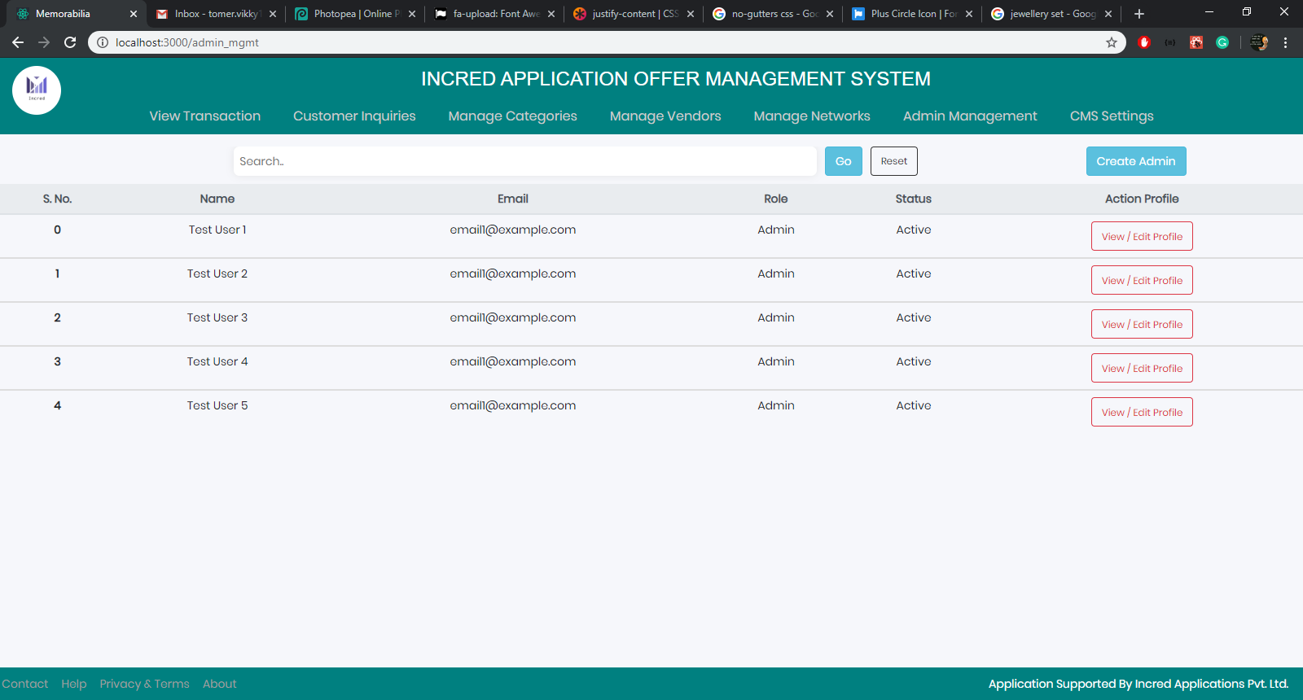

1. Admin Management  
   Page Purpose: Allows Super Admin to Add Users and Agents and assign Roles to them

* Only Accessible to Super Admin
* Super Admin creates Admins and Agents, and sets roles for Admins

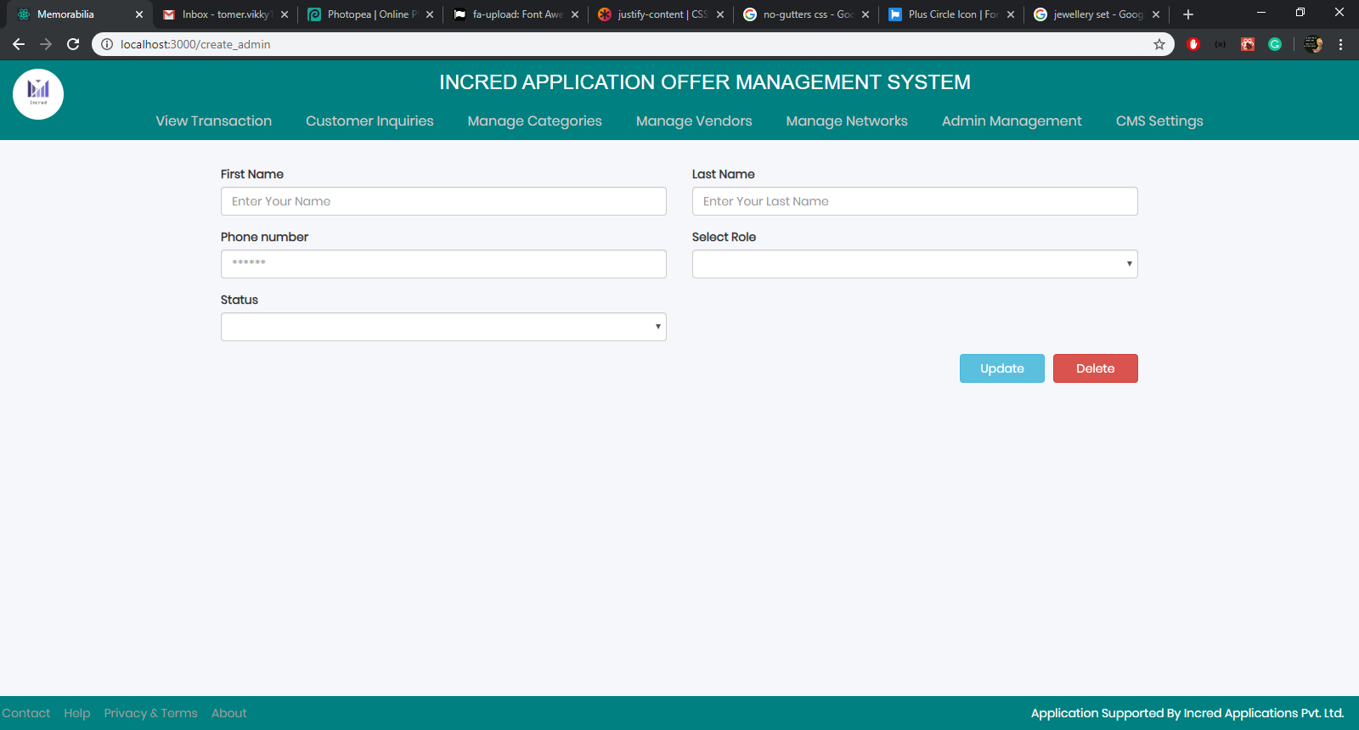

7a. Create Admin  
Page Purpose: Enter User Data for Access  
- Super Admin enters data for new Admin  
- **Editable Fields** of data are Name Last Name, Phone Number, Role and Status  
- Super Admin can Save and Delete an Admin’s profile

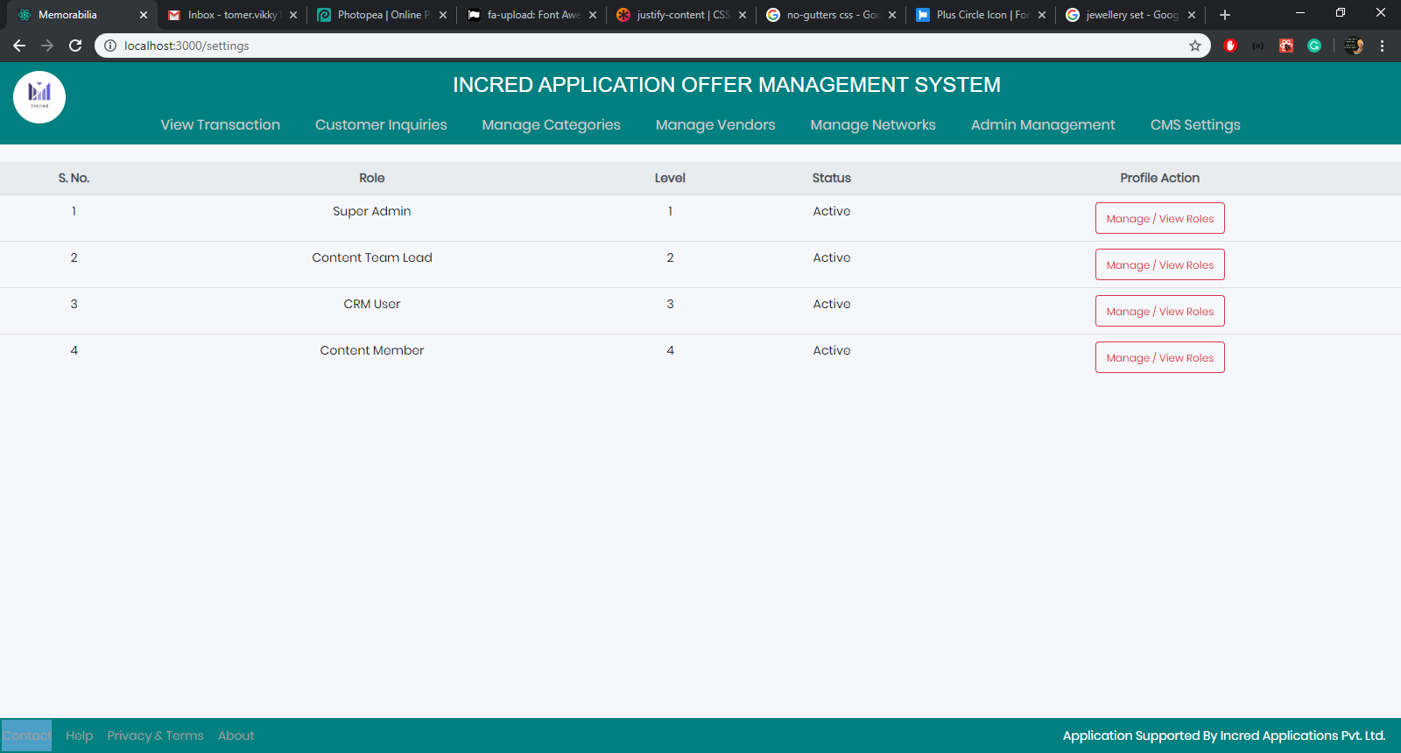

1. CMS Settings

* Super Admin sets viewing and actionable privileges for different admin roles